**Creating employee table:**

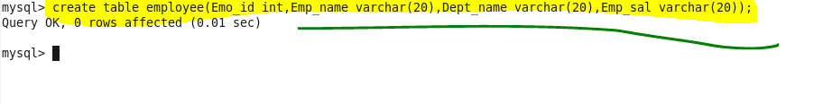

**Inserting values in table employee:**

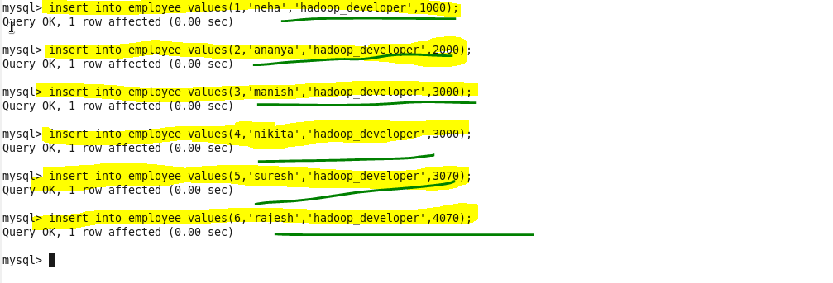

**Creating a directory named sqoop:**

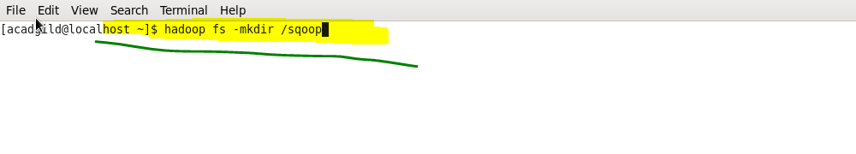

**At the browser:**

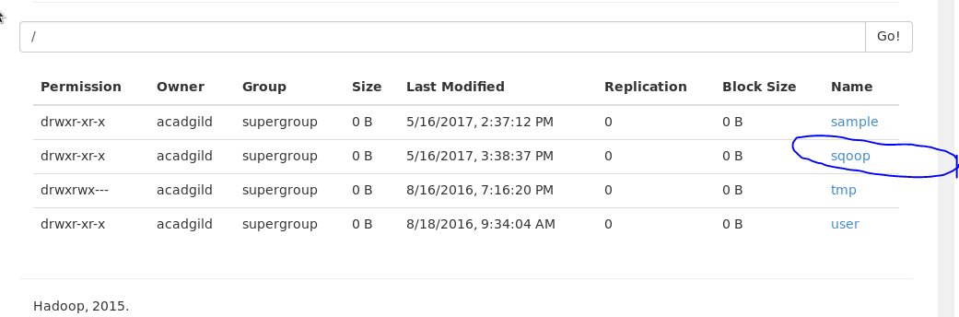

**Importing the data from mysql to hdfs directory using sqoop:**

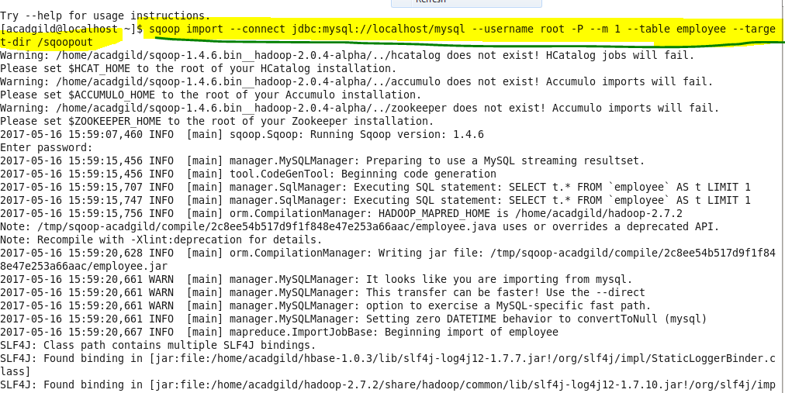

**Successfully imported:**

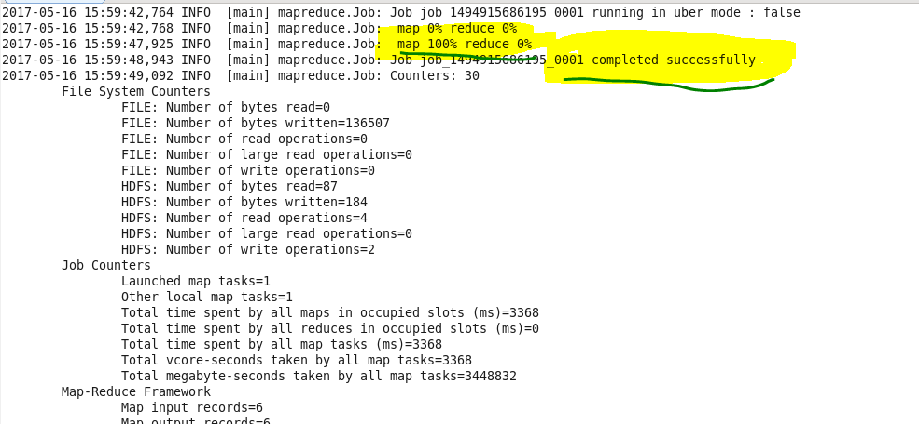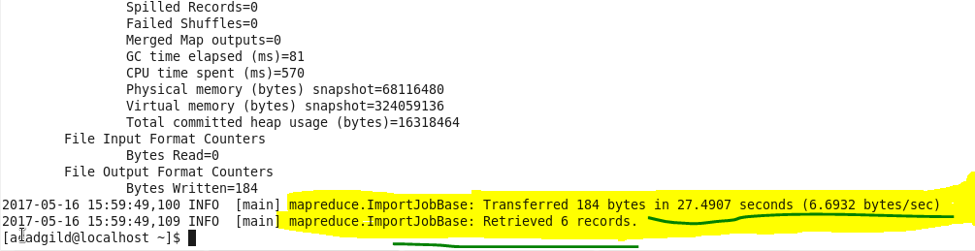

**Output :**

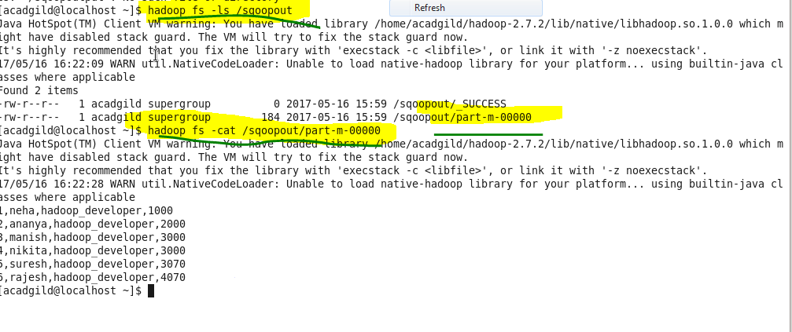

**Creating table employee2:**

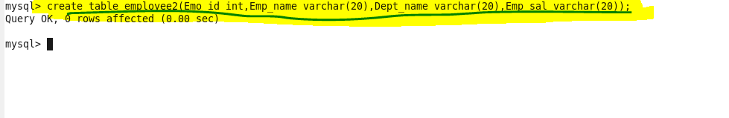

**Exporting data from hdfs to mysql:**

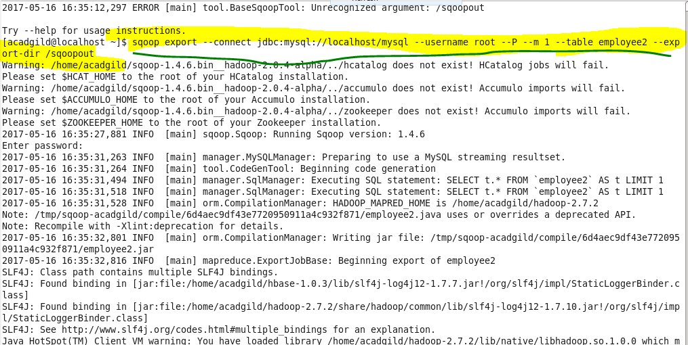

**Exported successfully:**

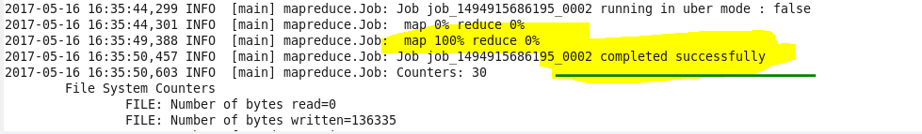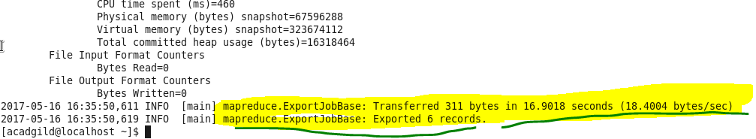

**Output:**